SQL Server Integration Services

# Module 03 – Lab 03: Connection strings

1. Open SQL Server Management Studio (SSMS).
2. Connect to SQL Server Instance.
3. Go to Security > Logins > Right-Click > New Login.  
   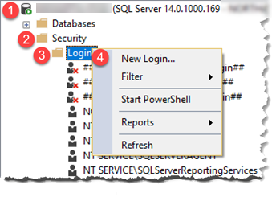
4. In Login – New dialog box select “SQL Server Authentication”. Enter in user name, passwords, and unselect “Enforce” options. Go to Server Roles and grant the user sysadmin. Click OK to create.

|  |  |
| --- | --- |
|  |  |

*Note: In production environment, granting sysadmin is not recommended. This is experimentation recommendation only.*

*Note 2: Confirm your SQL Server allows for SQL Authentication. By going to security settings on server and making server mixed authentication is enabled.*

1. Launch Visual Studio 2019 and create new integration services project.
2. Set up a connection manager to our database. In the bottom center pain under Connection Manger, right-click select New Ole-DB Connection.  
   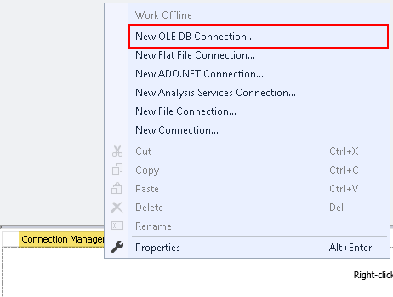
3. In Configure OLE DB Connect Manager, click New.  
   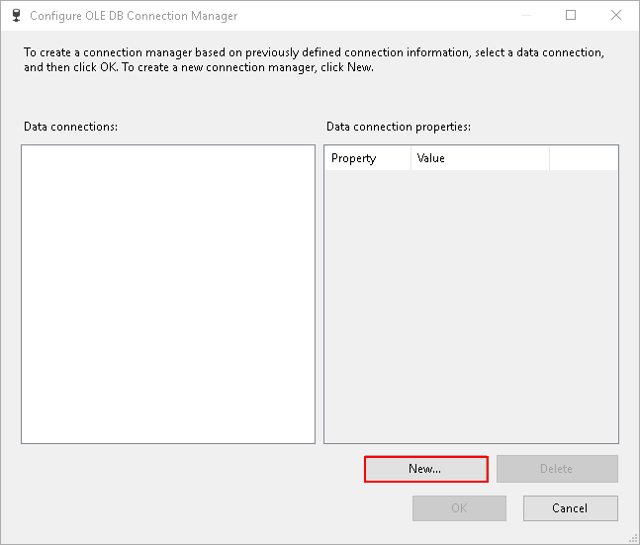
4. In connection manager, type the server name, select the database “AdventureWorks”, change Authentication type to SQL Server Authentication. Enter in username and password you created in step #4.  
   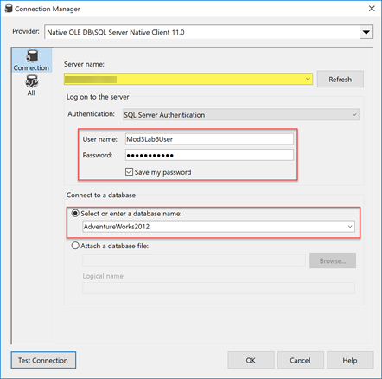
5. Click OK in Configure OLE DB Connection Manager. After the setup a new connection will show in the connection manager.  
     
   *Hint: Rename the connection manager to OLEDB.ServerName.DatabaseName.SQLAuth. This will make it easier to identify which driver is being used for the connection.*
6. Now parameterize this connection string. First, create new Parameters under project as per the below screenshot.  
   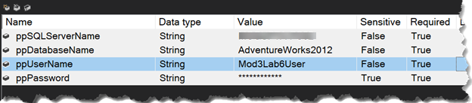  
     
   *Note: Take notice of the sensitive property under ppPassword. Set it to True, this is how SSISDB Catalog knows which values we need to be protected. Also note it gets converted to “*****” for display.*
7. Right-click on connection string and go to Properties. This will open the properties dialog box in bottom-right if not already open.

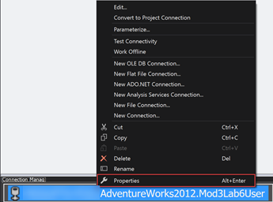

1. In properties dialog box, find Expressions. Click on the ellipse beside it to define the expression for connection string.  
   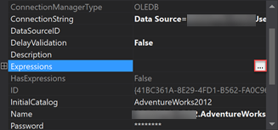
2. Select ConnectionString and click on the ellipse under expression to build the expression for connection string.  
   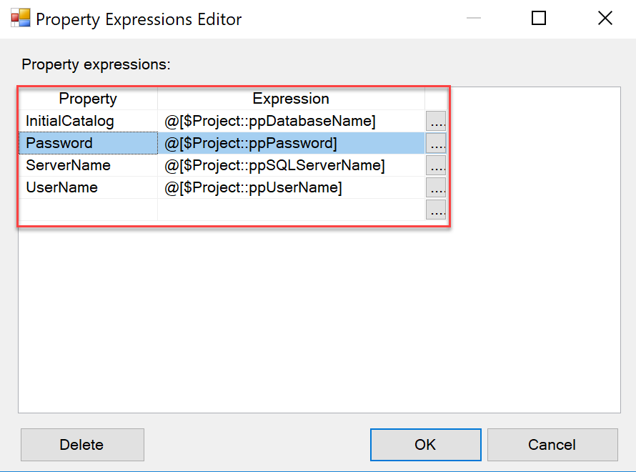
3. Create an Execute SQL Task and attach it to the connection manager. Execute “Select * FROM Person.Person”.
4. Execute package verify everything works as intended.